Title of the presentation can have up to 200 characters (including spaces; it is not checked here, but it is checked in the on-line submission system). Use Calibri 10 point bold
Presenting Author First Name and Surname in bold¹, Coauthor First Name and Surname², Next Coauthor First Name and Surname², More Authors in the same way
¹Name of Institution, City if needed for identification, Country; ²Name of Next Institution, City if needed for identification, Country; etc.; corresponding-author-e-mail@address
There is no limit for the number of words in the abstract. You can also place a small figure or references to clarify the message. However, the whole abstract, including Title, Authors, Affiliations, and all the text (including optional figure and references) must fit in the provided space (red frame).
YOU MUST NOT change the size of paper (A5), the size of margins (top 3cm, bottom 2cm, left 2cm, right 1.5cm), the type and size of font (Calibri 10p, except affiliation, figure legend and references – 9p), spacing between lines (single), or additional space added after each paragraph (6p). Follow the usage of boldface and italics applied in the template: use bold only for the title and the presenting author name (which normally should be the first author), and italics for affiliation and e-mail address. Otherwise use italics only for Latin names of species or words that are conventionally italicized. Do not use underlining or boldface for emphasis. DO NOT APPLY ANY "STYLES."
You can paste a figure inside the abstract. It must be pasted as a picture, NOT as an active, editable object or link. The entire figure, including its margin, must fit inside the red frame.
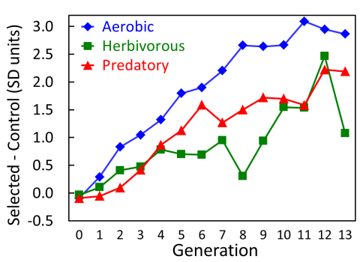
Figure: Use Calibri 9p font in figure legend. Begin the legend with the phrase "Figure:" to make clear where the legend begins.
You can also use references. Use a "minimalistic" convention of formatting references: Surname AB 2014 Article title. Journal title vol:pp-pp. You can omit article title to save space.

